Aleah Williams, Lemond Fofang, Jovin Tan
Texas A&M - Commerce
Fundraising Case Study Analysis
HHPS 521 – Finance & Economics in Sport
Dr. Logan Schuetz
January 9, 2023

Introduction
A high school athletics program is expected to provide several benefits to its athletes. All of these benefits are dependent on meeting the eligibility requirements. To participate, you must meet the following requirements which are to be medically cleared to participate, meet academic standards (which vary by state), meet age requirement, and agree not to violate social norms. If performance-enhancing drugs are discovered in your system, you may be disqualified. In order to meet these requirements, the school must pay for uniforms, equipment, umpires, and transportation. When working with a public school that provides a wide range of options, fundraising can become an important part of a team's annual strategy. Athletics and extracurricular activities allow students and families to sell goods to friends and family in order to acquire money for required equipment or other items.

Fundraising may be advantageous for the athlete. It gives kids something to focus on and invest in that has an impact on them, their team, and their community. Each student will take these teachings with them into the rest of their lives. Funds raised through fundraising activities can be used to support a wide range of school activities. It has the potential to effectively fund activities such as youth sporting events. These initiatives require funds for logistics and resources such as food and transportation. The constituency for a sport for fundraising grows as more students participate in it. Financial issues brought on by budget cuts for the school board, growing costs, and the economy. This essay's goal is to discuss how philanthropic fundraising strategies might be used to complement sports department budgets.

Fundraising examination

The financial strains on high school athletics are not expected to ease any time soon. In order to fund the athletic activities at their high schools, school administrators are exploring for new money sources(Yordy et al., 2018).The majority of the time, school administrators are in charge of budgeting, allocating resources, and defending their decisions. Budgets and administrators at schools are under tremendous financial strain as a result of the rising expense of public education in the United States and a rise in enrollment (Yordy et al., 2018). It is simple to understand why the majority of higher education institutions are investing in these extracurricular activities given the immediate and indirect benefits of a good sporting program. The issue is that these intuitions do not possess boundless capacities. Because of this, schools are working with former students and friends to support the expense of sporting activities(Yordy et al., 2018). Most people find it uncomfortable to ask for money. However, for those who are part of the industry and understand the reasons behind donors, it is much more than just requesting money; it is about building relationships. The importance of cultivating and maintaining relationships with donors and organizations cannot be overstate (Yordy et al., 2018)d. Donors support individuals and a cause, not a particular need. The more sincere relationships a fundraiser can create with donors and within your organization, the more likely it is that they will support your cause (Yordy et al., 2018).

As the demand for efficient revenue creation grows, the need for structured funding and recruitment techniques for interscholastic athletics grows (Yordy et al., 2018). These strategies must be easy to carry out and financially beneficial. Athletic directors and school officials are limited in the amount of time they can devote to fundraising. The first strategy is the cornerstone of any effective long-term planning program is annual funds. These initiatives are essential for a number of reasons even though they don't raise a lot of money (Yordy et al., 2018). First, yearly fundraising events bring in much-needed gift money to help pay operational costs. Second, more than any other program for development, the annual fund introduces people to donating and aids in the formation of a charitable habit. With a few rare exceptions, a donor's initial donation to a charity is often made to the annual fund.Third, the annual fund helps to build a relationship between the donor and the charity, which strengthens their commitment and involvement. Finally, the annual fund assists donors in preparing to make a large contribution. The second strategy is important gifts and being aware that a small number of individuals provide the majority of the funds. The greatest prospects must be identified because strong gifts require time to develop (Yordy et al., 2018).

Given present government financial policies, the failure of school bond issues, decreasing enrollment, school tax income, and overall worsening economic situations, the demand for sports fundraising is growing. Since many people view school sports as extracurriculars, funding for them is prioritized lower in the competition for limited funds and resources. Sixty-four percent of the schools said that they were anticipating or already had significant budget cuts, which would severely damage athletics and physical education (Yiannakis, 1984). For their programs, several schools have turned to additional sources of funding. According to data, booster clubs and other private donors have been the main source of fundraising for 59 percent of the schools (Yiannakis, 1984).With diverse degrees of success, other approaches like "pay to play" and the removal of junior varsity sports have also been tried.

As discussed, High school sports require uniforms, protective equipment, facility fees, transportation, salaries, and employee benefits; and as these costs rise, the financial burden is shifting from school budgets to students and their parents. Another avenue would be the potential impact of enacting pay-to-play policies is widespread (Eyler et al., 2019). Families of students who participate in an activity are required to pay a set fee to the school, which helps to pay for it. This is known as a "pay-to-play" policy. The pay-to-play marketing strategy has benefits and drawbacks. The pay-to-play model's advantages will let high schools finance their own internal operations. Less than 8% of all education spending in the US is covered by federal monies. The state pays for the majority of primary and secondary education spending—more than 90%. Pay-to-play might help maintain some sports, clubs, or programs accessible to students, but it would not make up for the money that was lost from school budgets. Pay-to-play might negatively impact a player's choice of team or sport. One example of a disadvantage of pay-to-play is that paying a fee "to play" begs the question of whether it is expected that the student will actually "play." Parents may believe that by paying a fee, they can expect their children to participate in all games. That is highly unlikely in high school sports, particularly varsity sports. In this situation, coaches and athletic directors would be uncomfortable.

Fundraising is essential to most successful programs and is included in the annual budget. After paying for the essential items typically there is not a whole lot left over to enhance the sporting experience. According to (Courtney Allen HFC Mesquite Horn HS “Personal Communication Jan 4th 2023)” My goal is to raise 20 thousand dollars every year, when we reach our goal our program continues to grow financially. Safety is very important and these funds allow me to invest in our kids' safety. The top of the line football helmets cost $1500 a piece, and between varsity, junior varsity, and our two freshman teams we have about 240 athletes that need helmets and these helmets have expiration dates on them and must be maintained by a certified professional every year. That means you buy a set number of helmets every year to account for the helmets you lose to expiration, as well as growth of your program.

Practical recommendations for improvement

Students benefit physically and academically from sports and clubs.High school athletics has many benefits, but there are two more that should not be overlooked: they keep students in school and on pace for success, and they keep teenagers active and healthy. Pay-to-play is only a reliable method for funding if it keeps the sporting club or program from being canceled or discontinued. Fundraising success is heavily reliant on the working relationship between a coach and his or her team, as well as a realistic and accurate assessment of the current budget before specific needs are identified. A collective effort should be made to establish objectives, gain awareness, and improve the organization's or program's public perception (Balog & Connaughton, 2002).

Sports give a large majority of young people purpose and a reason to come to school. Not every young person can see the value of education at a young age, but since they incorporated no pass, no play into public schools graduation rates amongst your men have shown incremental increases amongst athletic participants in low socioeconomic areas. Interest in sport can encourage a student to keep their grades up in order for them to stay eligible to compete in high school athletics. Many schools find less spectacular ways to bolster their limited funds. There are currently booster clubs for every sport. They encourage parental involvement in the school, relieve members of staff of some duties, and in many situations, they can cover a significant portion of a sport's expenses while abiding by regulations for tax-exempt organizations, maintain proper bookkeeping and management, and be informed of district and school policies.

Advertisement and promotional partnerships can also help boost a school’s athletic funds. Typically, sponsors pay to have a certain company’s name advertised or promoted on scoreboards or during announcements. It is more typically seen in university sports, and sometimes avoided by high schools in an attempt to shy away from promoting an unpopular product or company. However, such funding can be crucial to a high school athletics program. Turning to broadcasting rights can also be another way for schools to fund their athletic program. Many schools have even adopted the approach of selling the naming rights of their stadium. Stadium naming and broadcasting rights tend to come at a high cost and can be seen as an effective way to annually bolster a high school athletic program’s funding.

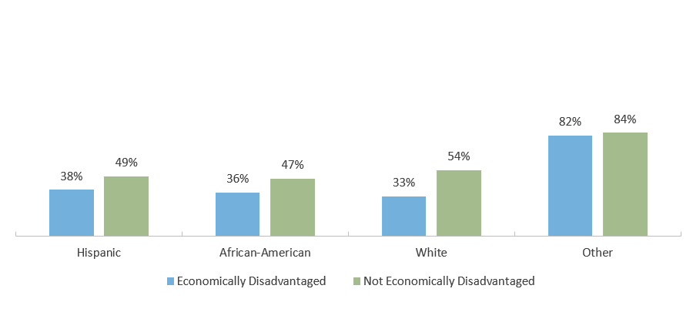
Percentage of 2019-2020 Texas High School Graduates Enrolled in Texas Higher Education in Fall 2020, by Ethnicity
(Trelliscompany.org)

These statistics just reemphasize there is still a large portion of individuals that need public funds in order to survive. Coaches in low socioeconomic communities understand it easier to raise money through fundraising, then it is to depend on parental donations.

Conclusion
Each school district will have to determine the funding ratio based on community support that is appropriate for each school, each community, and each athletics program. To the greatest extent possible given their budgets, schools should support their athletics program to the best of their ability. It is important that the funding be based on needs and program requirements that are easily recognisable.

It has been established that engagement in sports is strongly correlated with student success later in life. Government, commercial, and industrial leaders frequently attribute their current triumphs to their involvement in athletic activities. It is our responsibility to ensure that students are ready to participate successfully in our democracy. What better way for schools to accomplish this than by sponsoring athletic programs that push and involve students in worthwhile, real-world activities that might produce the next Tom Brady or President of the United States.

References

Balog, S., & Connaughton, D. (2002, November). Fundraising for Interscholastic Athletic and Recreation Programs. Strategies, 16(2), 37–38. https://doi.org/10.1080/08924562.2002.10591005
Eyler, A. A., Piekarz-Porter, E., & Serrano, N. H. (2019, May). Pay to Play? State Laws Related to High School Sports Participation Fees. Journal of Public Health Management and Practice, 25(3), E27–E35. https://doi.org/10.1097/phh.0000000000000813
Yiannakis, A. (1984, September). Survival Strategy for High School Sports. Journal of Physical Education, Recreation & Dance, 55(7), 20–22. https://doi.org/10.1080/07303084.1984.10630591

Yordy, B., Pierce, D., Blom, L., & Bussell, L. A. (2018). Interscholastic and intercollegiate athletics development in the United States. Alternative Models of Sports Development in America, 18–37. https://doi.org/10.2307/j.ctv224twp0.7

